

**High Level Design (HLD)**

**Bike Share Prediction**

Revision Number : 1.2

Last Date of revision : 10/06/2023

Document Version Control

|  |  |  |  |
| --- | --- | --- | --- |
| Date Issued | Version | Description | Author |
| 02-06-2023 | 1.0 | Initial HLD – V1.0 | SAHIL JOSAN |
| 04-06-2023 | 1.1 | Design Flow | SAHIL JOSAN |
| 10-06-2023 | 1.2 | Performance Evaluation Conclusion | SAHIL JOSAN |

**Contents**

* Abstract……………………………………………………………………………………………………………...3

1. Introduction……………………………………………………………………………….…….…………....4

1.1 Why this High-Level Design Document ?……………………………..………………....4

1.2 Scope…………………………………………………………………………………………………………….4

1.3 Definition……………………………………………………………………………………………………….5

* 2. General Description………………...…………………………………………………………………...5

2.1 Problem Perspective…………………………………………………………...…………………....5

2.2 Problem Statement……….........………………………………………………....……………....5

2.3 Proposed Solution………………………………………………………………..………..…………..5

2.4 Technical Requirements……………………………………………………………………………..5

2.5 Data Requirements………………………………………………………………………………………6

2.6 Tools Used…………………………………………………………………………………………………….6

2.7 Constraints…………………………………………………………………………………………………….7

2.8 Assumptions………………………………………………………………………………………………...7

* 3. Design Details………………..……………………………………………………….……..……………….8

3.1 Process Flow…………………………………………………………………….…………..………………8

3.2 Model Training and Evaluation……………………………………………………………………8

3.3 Deployment Process…………………………………………………………………………………….9

3.4 Logging…………………………………………………………………………………………………………..9

3.5 Error Handling………………………………………………………………………………………………..9

* 4. Performance Evaluation……………………….…………………………………………..…………..10

4.1 Reusability……….……………………………………………………………………………..………..…..10

4.2 Application Compatibility………………………………………………………………..……..…..10

4.3 Resource Utilization……………………………………………………………………………..………10

* 5. Conclusion……………………….…………………………………………….……………………..…………10

**Abstract**

Bike sharing systems are new generation of traditional bike rentals where whole process from membership, rental and return back has become automatic. Through these systems, user is able to easily rent a bike from a particular position and return back at another position.

Apart from interesting real world applications of bike sharing systems, the characteristics of data being generated by these systems make them attractive for the research. Opposed to other transport services such as bus or subway, the duration of travel, departure and arrival position is explicitly recorded in these systems. This feature turns bike sharing system into a virtual sensor network that can be used for sensing mobility in the city.

I am considering variables as season, yr,mnth, holiday, weekday, workingday, weathersit,

Temp, atemp, hum, windspeed, casual, registered to predict the count of total rental bikes

That will be required.

**1. Introduction**

**1.1 Why this High-Level Design Document ?**

The purpose of this High-Level Design (HLD) Document is to add the necessary detail to the current project description to represent a suitable model for coding. This document is also intended to help detect contradictions prior to coding, and can be used as a reference manual for how the modules interact at a high level.

The HLD will :

* Present all of the design aspects and define them in detail
* Describe the user interface being implemented
* Describe the software interfaces
* Describe the performance requirements
* Include design features and the architecture of the project
* List and describe the non-functional attributes like:
* Security
* Reliability
* Maintainability
* Portability
* Reusability
* Application compatibility
* Resource utilization
* Serviceability

**1.2 Scope**

The HLD documentation presents the structure of the system, such as the databasearchitecture, application architecture (layers), application flow (Navigation), and technologyarchitecture. The HLD uses non-technical to mildly-technical terms which should beunderstandable to the administrators of the system.

**1.3 Definition**

|  |  |
| --- | --- |
| Term | Description |
| BSP | Bike Share Prediction |
| Jupyter – Notebook | It is an interactive computational environment, in  which we can combine code execution, text, plots and rich media. |
| Streamlit | It is a platform as a service (pass) that enables developers to build, run and operate application  in the cloud. |

**2. General Description**

**2.1 Problem Perspective**

The Bike Share Prediction is a machine learning model that helps companies to predict how many number of bikes will be required on that particular day based on some input data.

**2.2 Problem Statement**

The main goal of this model is to predict Bike Share counts based on the input features

**2.3 Proposed Solution**

To solve the problem, we have created a user interface for taking the input from the user

To predict Count of Bikes Shared using our trained ML Model after processing the input and at last the predicted value from the model is communicated to the user.

**2.4 Technical Requirements**

As technical requirements, we don't need any specialized hardware for virtualization of the application. The user should have a device that has the access to the web and the fundamental understanding of providing the input. And for the backend, we need a server to run all the required packages to process the input and predict the desired output.

**2.5 Data Requirements**

The Data requirements totally supported the matter statement and also the dataset is accessible on the Kaggle within the file format of (.zip). Because the main theme of the project is to induce the expertise of real time issues, we have a tendency to transform the information into the prophetess database and commerce it into csv format.

**2.6 Tools used**

Python programming language and frameworks such as Numpy, Pandas, Scikit-learn, VS Code, git and streamlit are used to build the whole model

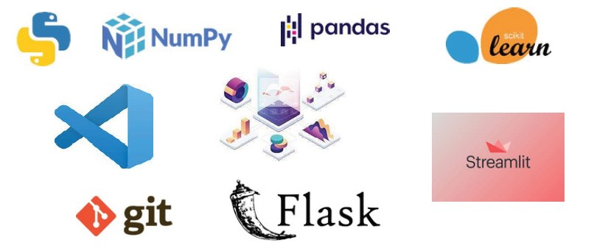

* VS Code is used as IDE.
* For visualization of the plots, Matplotlib, Seaborn and Plotly are used.
* Streamlit is used for deployment of the model.
* Front end development is done using Streamlit.
* Python Flask is used for backend development.
* GitHub is used as version control system.

**2.7 Constrains**

The system must be user friendly, as automated as possible and users should not be required to know any of the workings.

**2.8 Assumptions**

The main objective of the project is to implement the use cases as previously mentioned (2.2 Problem Statement) for new dataset that comes through source. Machine Learning based model is used for detecting the above-mentioned use cases based on the input data. It is also assumed that all aspects of this project have the ability to work together in the way the designer is expecting

**3. Design Details**

**3.1 Process Flow**

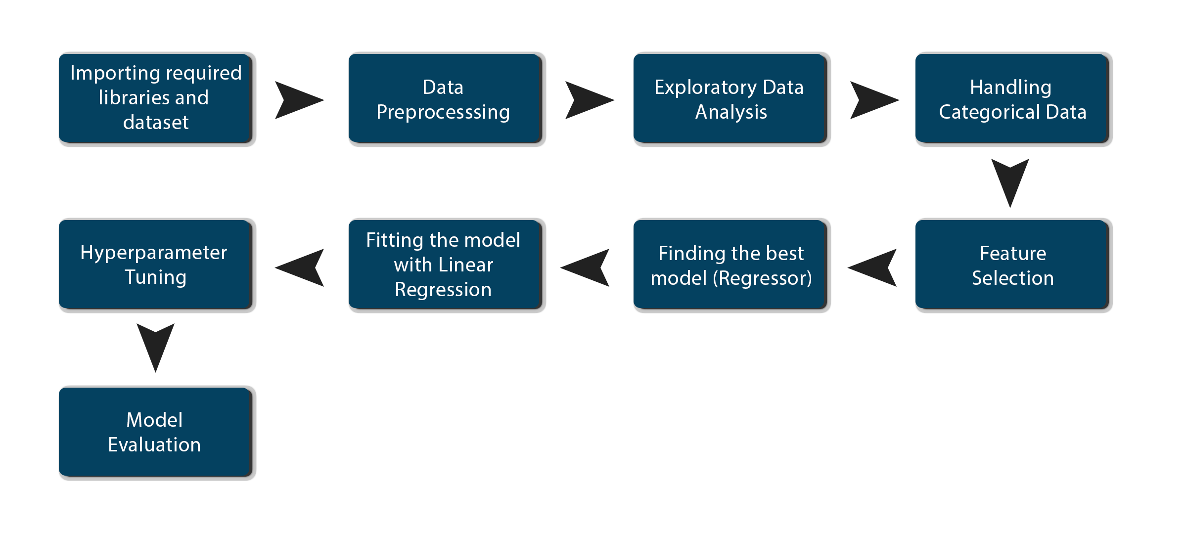

**3.2 Model Training and Evaluation**

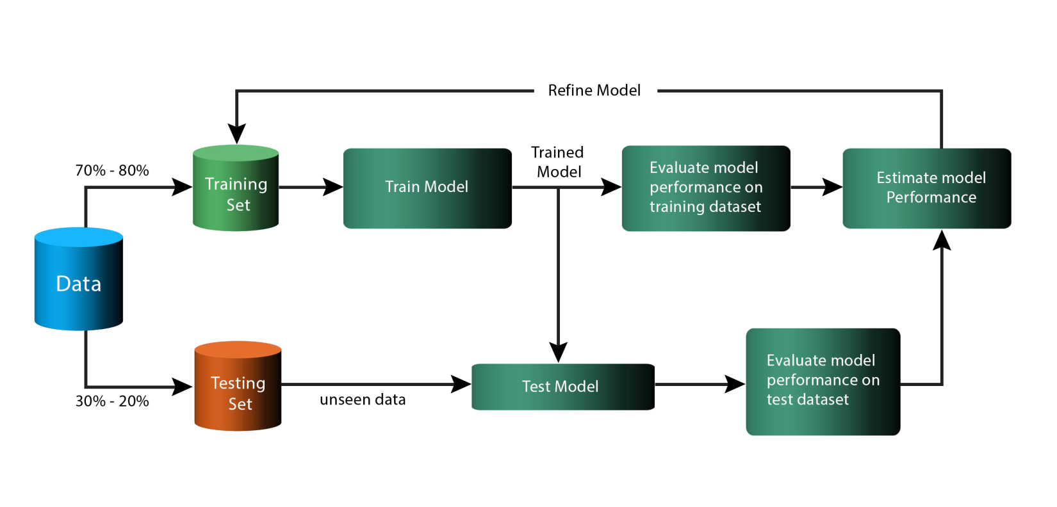

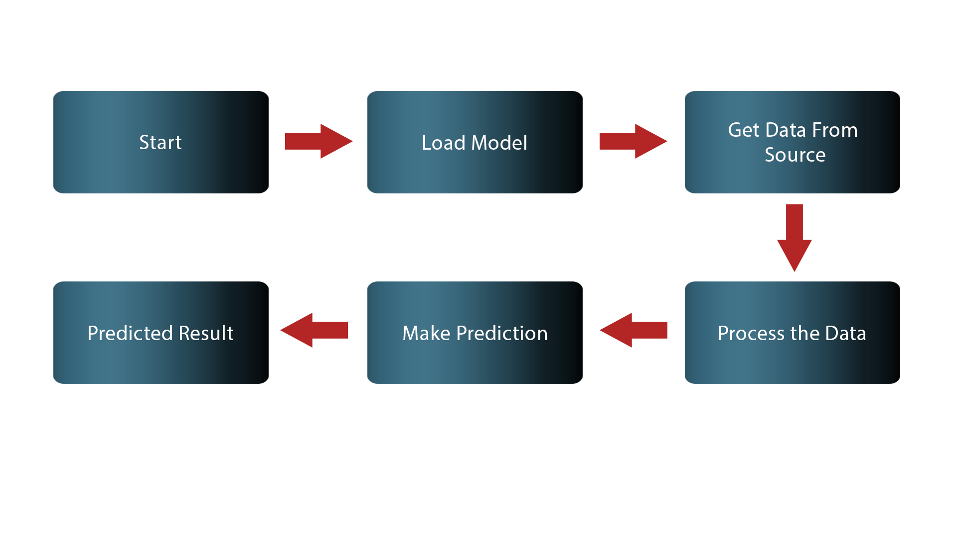**3.3 Deployment Process**

**3.4 Logging**

In logging, each time an error or an exception occurs, the event is logged into the system log filewith reason and timestamp. This helps the developer to debug the system bugs and rectify the error.

**3.5 Error Handling**

Should errors be encountered, an explanation will be displayed as to what went wrong?

An error will be defined as anything that falls outside the normal and intended usage

**4. Performance Evaluation**

The machine learning based Bike Sharing Prediction project predicts count of rental bikes that will be shared on the that day.

**4.1 Reusability**

The code written and the components used should have the ability to be reused with no problems.

**4.2 Application Compatibility**

The different components for this project will be using Python as an interface betweenthem. Each component will have its own task to perform, and it is the job of the Python to ensure proper transfer of information.

**4.3 Resource Utilization**

When any task is performed, it will likely use all the processing power available until that function is finished.

**4.4 Deployment**



**5 Conclusion**

The Bike Share Prediction System will predict the count of rental bikes that will be shared on specific day with the trained knowledge with set of rules. The company executive can use this system to predict the approximate count of rental bikes.